QUICK START  PEMF FIRST OPTIONAL HEAT  1 Position Wrap the active area flat and comfortably around the intended body area.  2 Connect Inspect the cord and controller, then connect the device as shown on its product label.  3 Power on Press the Power button. The display defaults to 35°C and 8 hours.  4 Select PEMF Press the PEMF button to cycle from P0 through P8. P0 turns PEMF off.  5 Optional heat Use Plus or Minus to select a comfortable temperature. Start low.  6 Finish Turn off, unplug, and allow the wrap to cool before storing.  PEMF SETTINGS  The PEMF function automatically stops after 30 minutes by default. Heat timing is controlled separately. | IMPORTANT SAFETY INFORMATION  Do not use  - With a pacemaker, implanted defibrillator, insulin pump, neurostimulator, or other implanted electronic device.  - While sleeping, bathing, showering, or in any wet environment.  - On infants, children, anyone unable to report discomfort, or areas with open, infected, or severely irritated skin.  - If the wrap, controller, plug, connector, or cord is damaged.  Warnings and cautions  - Consult a healthcare professional before use if pregnant, under medical care, or if you have impaired sensation or circulation.  - Begin with the lowest comfortable heat setting. Check the skin regularly and stop if heat feels excessive.  - Do not fold, bunch, sharply crease, pierce, crush, or place heavy objects on the active area.  - Stop use for pain, dizziness, burning, redness, irritation, or unusual discomfort.  CARE AND STORAGE  Unplug and cool before cleaning. Wipe with a soft, lightly damp cloth. Do not immerse, machine wash, dry clean, or use solvents. Store flat or loosely rolled in the carrying case.  CUSTOMER SUPPORT  Distributed by United Yoram Inc.  Brooklyn, NY 11236  drfranklyns.com  support@drfranklyns.com  Instagram @drfranklyns  Brand Dr. Franklyn’s | Model PEMF-02  Revision 1.1 | September 2026 |   MagniPulse Pro  P E M F T H E R A P Y W R A P  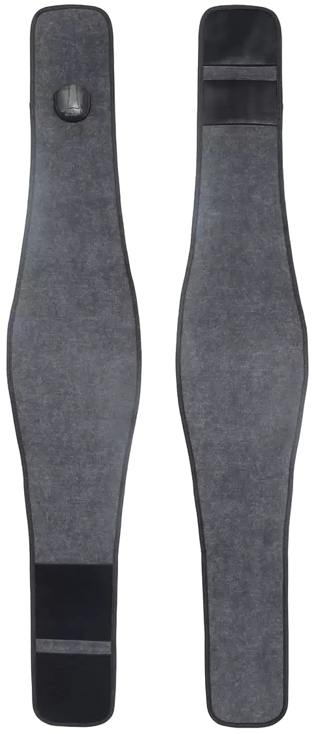  Targeted pulsed electromagnetic field therapy with optional heat  MODEL PEMF-02  READ INSTRUCTIONS COMPLETELY BEFORE USE
  P0 Off | P1 3 Hz | P2 8 Hz
  P3 10 Hz | P4 25 Hz | P5 40 Hz
  P6 48 Hz | P7 56 Hz | P8 64 Hz
  SCAN FOR  PRODUCT DETAILS | 

ABOUT THE MAGNIPULSE PRO  The MagniPulse Pro is an adjustable wrap that delivers selectable pulsed electromagnetic field frequencies to a targeted body area. Optional controlled heat may be used separately or together with PEMF for added comfort.  WHAT IS PEMF  PEMF therapy uses controlled electromagnetic pulses without forceful pressure or physical stimulation. It is intended to support personal wellness, relaxation, comfortable movement, and post-activity recovery.  INTENDED USE  - Supports temporary relief of minor muscle and joint discomfort.  - Supports relaxation and everyday mobility.  - Provides targeted, non-invasive wellness support at home or in a professional wellness setting.  PRODUCT SPECIFICATIONS  PACKAGE CONTENTS  Therapy wrap | Integrated controller and power cord | Carrying case | User manual | CONTROLLER AND DISPLAY  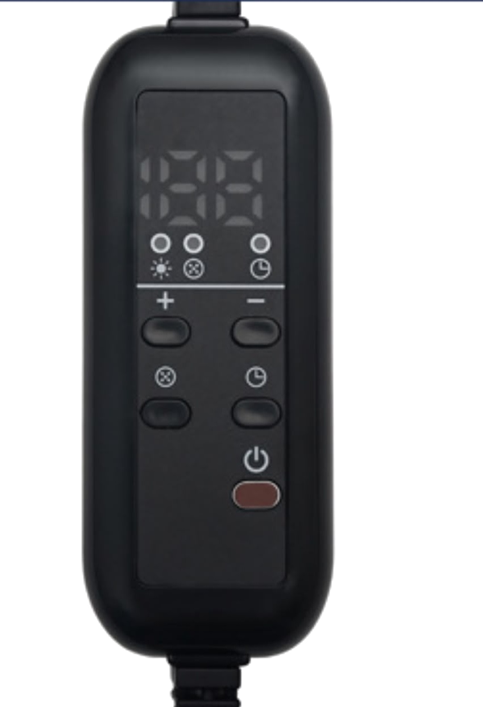  Power: turns the device on or off.  Plus and Minus: adjust the selected temperature or timer value.  PEMF Frequency: cycles through P0-P8. P0 turns PEMF off.  Timer: selects a heat operating time from 1 to 12 hours.  Display: shows active temperature, PEMF, and timer functions.  PEMF FREQUENCY SETTINGS  P0 is off. P1-P8 provide selectable frequencies from 3 Hz to 64 Hz. Frequency labels identify output settings only and do not promise a specific medical result.  HEAT AND TIMER  The temperature range is 10-70°C (50-158°F). Start at the lowest comfortable setting and increase gradually. The controller defaults to 35°C and an 8-hour heat timer. Remain awake and monitor the skin throughout use. | HOW TO USE  1 Inspect Check the wrap, controller, connector, cord, and plug before every use.  2 Position Place the active area flat over the intended body area and secure the wrap comfortably. Do not overtighten.  3 Connect Connect the device only as directed on the product label.  4 Power on Press Power. Confirm the display illuminates.  5 Select PEMF Press the PEMF Frequency button until P1-P8 displays. Choose P0 when PEMF is not wanted.  6 Adjust optional heat Use Plus or Minus to select a comfortable temperature. Start low.  7 Set heat time Press Timer, then use Plus or Minus to select 1-12 hours. Do not sleep during use.  8 Monitor Check comfort, fit, and skin condition regularly throughout the session.  9 Finish Press Power, unplug the device, loosen the wrap, and allow it to cool before storage.  TROUBLESHOOTING  - No display: check the outlet, connection, cord, and Power button.  - No PEMF: select P1-P8; P0 means PEMF is off.  - No heat: select a temperature above ambient and allow time to warm.  - Damage, error, or unusual heat: turn off, unplug, and contact customer support.  Individual experiences may vary. This product is not intended to diagnose, cure, or prevent disease.
  Model | PEMF-02
  Size | 25 x 140 cm / 9.8 x 55.1 in
  PEMF | P0-P8; 3-64 Hz
  Heat | 10-70°C / 50-158°F
  Heat timer | 1-12 hours
  PEMF timer | 30-minute default shutoff
  Power | 280 W ±20% factory rating
  Default | 35°C and 8 hours
  P0 Off | P1 3 Hz | P2 8 Hz
  P3 10 Hz | P4 25 Hz | P5 40 Hz
  P6 48 Hz | P7 56 Hz | P8 64 Hz

